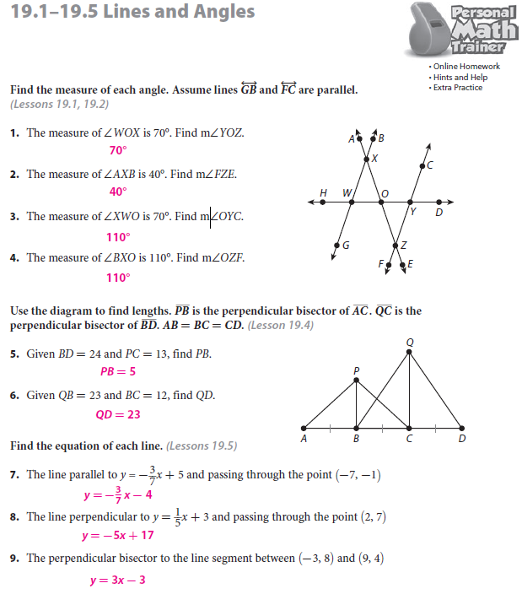

**\*\*\*Must use Pythagorean theorem on triangle PBC!!!\*\*\***